**Communication Labs**

**Spring 2024**

**Assignment 5**

**Portfolio**

Prepared by:

Stefania Petre (sxp8191)

Instructor:

Dr Evi Mansor

# INTRODUCTION

The fifth assignment for the Communications Lab class required the creation of a comprehensive portfolio. This assignment proved easier compared to previous projects. By utilising a template from W3Schools and adjusting it as necessary, the process became streamlined and efficient.

The portfolio showcases a diverse range of projects, demonstrating the growth and creativity that has been shown throughout the semester. From refining the structure to incorporating interactive elements, each page exemplifies the ability to effectively apply web development techniques. The final result is a polished and comprehensive portfolio that fulfils the assignment's requirements while highlighting the skills acquired during the course.

# PROJECT DESCRIPTION

## Project timeline

| **Phase** | **Deadline** | **Person** | **W 1** | **W 2** | **W 3** |
| --- | --- | --- | --- | --- | --- |
| **Ideation/Plan** |  |  |  |  |  |
| * Prepare timeline |  | Stefania | 4/28 |  |  |
|  |  |  |  |  |  |
| * Brainstorm the story/idea |  | Stefania | 4/28 |  |  |
|  |  |  |  |  |  |
| **Design** |  |  |  |  |  |
|  |  |  |  |  |  |
|  |  |  |  |  |  |
|  |  |  |  |  |  |
| * Design wireframe |  | Stefania | 05/01 |  |  |
|  |  |  |  |  |  |
| **Development** |  |  |  |  |  |
| * Edit the Template |  | Stefania |  | 05/03 |  |
| * Edit video / sound |  | Stefania |  | 05/03 |  |
| * Develop website |  | Stefania |  | 05/03 |  |
| * Prepare report |  | Stefania |  | 05/03 |  |
| * Create Github |  | Stefania |  | 05/04 |  |
|  |  |  |  |  |  |
| **Delivery** |  |  |  |  |  |
| * Upload the website |  | Stefania |  | 05/08 |  |
| * Submit project on Brightspace   - Report  - Project website link  - Github repository link |  | Stefania |  | 05/05 |  |

## Storyline

The portfolio serves as a digital showcase of assignments completed for the Communications Lab course. It begins with an introduction, offering a basic idea on the person, and is organized to highlight every single project created during the semester. Each section tells the story of progression and growth, demonstrating how concepts learned in class were applied in creative and unique ways.

From interactive art installations to web-based visualizations, each project exemplifies the creator's ability to effectively apply web development and interactive media techniques. The clear storyline guides viewers through a cohesive narrative that reflects both technical skill and artistic exploration.

**2.3 Wireframe**

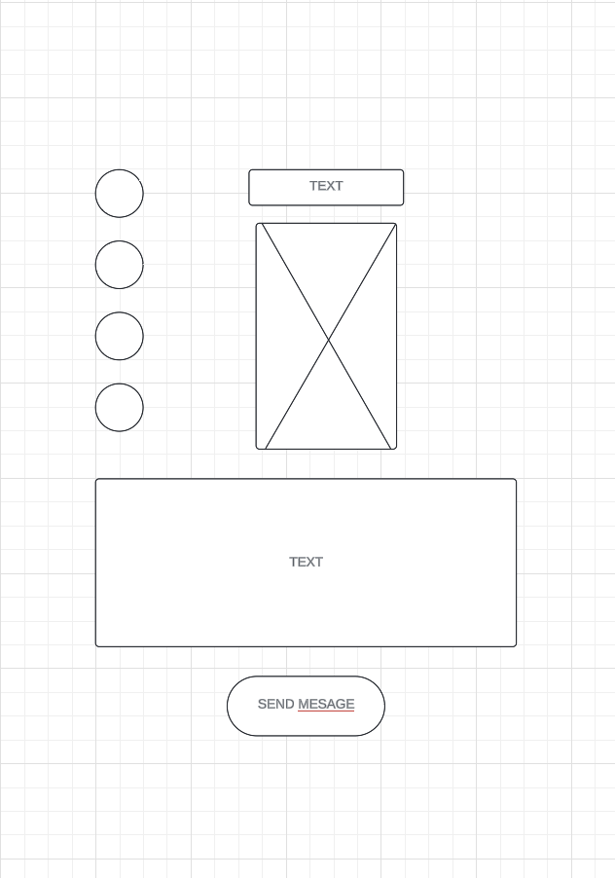

**Wireframe Analysis**

The wireframe presented is a simple yet effective layout designed to serve as the foundation for a digital portfolio. The layout is organized into distinct sections:

**1. Navigation Panel (Left):** A series of circular navigation buttons on the left provide a consistent way to navigate through different sections of the portfolio.

**2. Header (Top-Center):** A concise text header introduces the content, guiding the viewer's attention.

**3. Main Content Area:**

- Image/Media Section: A placeholder for an image or media element allows for visual engagement, providing an impactful introduction to the content.

- Text Block: Directly below the image/media section is a large text block to convey detailed information.

**4. Call to Action (CTA):**

- **Send Message Button**: The "Send Message" button encourages interaction and engagement, serving as a call to action.

**5. Footer:** A final text block at the bottom provides additional context or information, accompanied by another "Send Message" button.

The wireframe's minimalist design ensures that viewers can easily navigate and focus on the portfolio's essential elements. Its structure is both visually appealing and functional, offering a clear pathway for users to explore the creator's work in an organized manner.

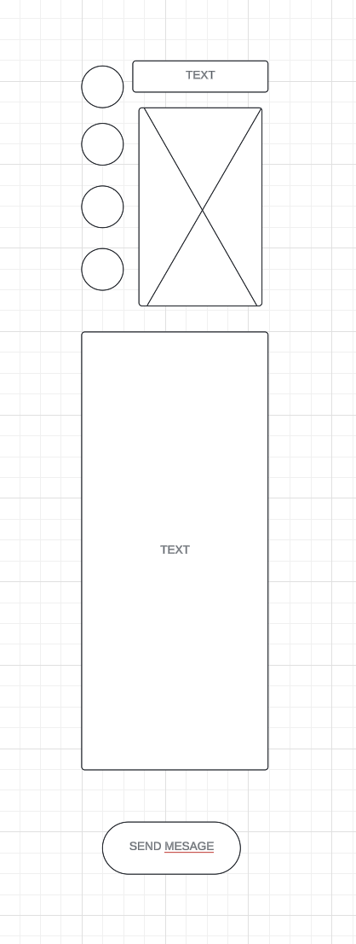

# REFLECTION

The portfolio for the fifth assignment provides an excellent opportunity to reflect on the learning experience of the Communications Lab course. The overall experience of putting together this digital display was both satisfying and informative.

The Communications Lab class was really helpful in acquiring the skills and confidence needed for this assignment. It provided extensive training in web development and interactive media, which was essential for building and implementing an appealing portfolio. Each task built on the preceding one, resulting in a coherent plot that effectively depicted progress and inventiveness.

In summary, this portfolio represents the technical and creative talents developed throughout the course. The Communications Lab class was critical in giving the required tools, feedback, and motivation. This experience has been not only academically rewarding, but also a critical milestone in the road to master interactive media.

# REFERENCES

1. <https://www.w3schools.com/w3css/tryw3css_templates_dark_portfolio.htm>